**Experiment**

**Aim:** To design a Push Button controlled LED such that when we push the button, the LED starts glowing and when we release the button, the LED stops glowing.

**Apparatus:**

Arduino Board, LED, Resistance - 220ohm, Breadboard, Wires, bell.

**Circuit Diagram:**

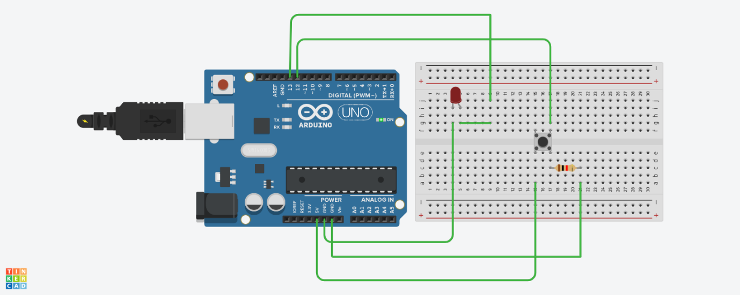

**Theory:**

**Concepts Used –**  
A circuit is made in which 2 digital pins are used where a pin (say 7) is connected to a buzzer which is further connected to ground. Now another pin (say 12) is connected to switch. One end of the switch is connected to 5V supply and intersection of pin 12 and switch is connected to resistor which is connected to ground from another end. Value of resistance is very high. The resistors are used to resist the flow of current. Coding is done in such a way that when switch is pressed for the 1st time buzzer starts buzzing and again when the switch is pressed the 2nd time buzzer stops buzzing.

**Learning and Observations -**

1. We can recognize the positive and negative terminals of an LED even without using a Multimeter. The longer leg of the LED is the positive terminal (or the anode) and the smaller leg is the negative terminal (or the cathode).
2. Another way of finding the positive and negative terminals of an LED is to see the parts inside the LED. The larger part is the negative side (i.e. the cathode) and the smaller part is the positive side (i.e. the anode).

**Problems and Troubleshooting:**

1. The first problem that we faced was due to the cable of the Arduino which was not working properly. This problem was solved by using another cable.
2. The proper port of the Arduino was not selected. After it was selected the Arduino worked perfectly.
3. The code had some errors like proper pin was not mentioned, etc. But after modifying the code, everything worked perfectly fine.

**Precautions:**

1. The Arduino and its cable should be working properly.
2. Proper port of the Arduino should be selected.
3. The connections should be made neat and clean.
4. Desired resistance should be used.

**Result:**

Glowing of LED by pressing the push button was verified after uploading the project.